Windows Workgroup Discovery – No Scripting

Contents

1. Introduction 1

2. Create Scan template 1

a. Create Machine Scan template 1

b. Create Account Scan template 1

3. Create Discovery Scanner 2

a. Create Machine Scanner 2

b. Create Account Scanner 2

4. Copy password changer 3

5. Copy Secret template 4

6. Create Discovery Source 4

|  |  |  |
| --- | --- | --- |
| Version | Date | Author |
| Draft | 25-Oct-2020 | Mahesh Bitla |
| 1.0 | 29-Oct-2020 | Mahesh Bitla |

## Introduction

This document explains the detailed steps required for Windows Discovery (Non Domain Joined or Workgroup) without using PowerShell scripting.

PS NOTE: This discovery doesn’t work with IP Range or CIDR.

## Create Scan template

## Create Machine Scan template

* Navigate to Admin 🡪 Discovery 🡪 Extensible Discovery 🡪 Configure Scan Templates
* Navigate to machine tabs and create new scan template

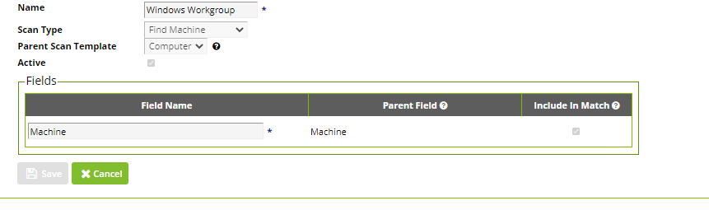

## Create Account Scan template

* Navigate to Admin 🡪 Discovery 🡪 Extensible Discovery 🡪 Configure Scan Templates
* Navigate to accounts tabs and create new scan template

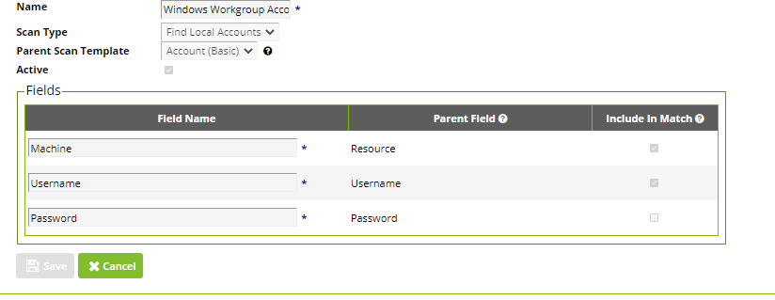

## Create Discovery Scanner

## Create Machine Scanner

* Navigate to Admin 🡪 Discovery 🡪 Extensible Discovery 🡪 Configure Discovery Scanners
* Click on machines tab and create new scanner

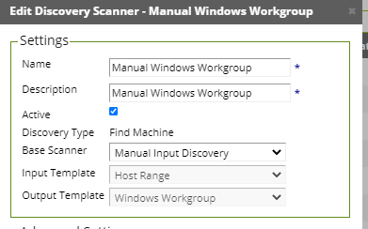

## Create Account Scanner

* Navigate to Admin 🡪 Discovery 🡪 Extensible Discovery 🡪 Configure Discovery Scanners
* Click on accounts tab and create new scanner

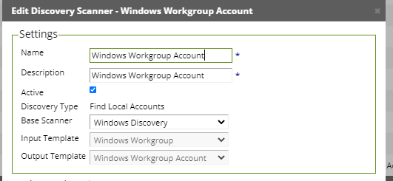

## Copy password changer

* Navigate to admin 🡪 Remote Password Changing 🡪 Configure password changers
* Create new Password Changer and select base password changer as Windows account

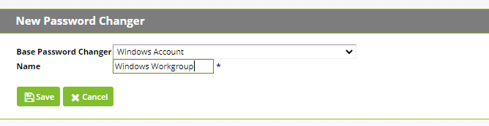

* Once new password changer is created, navigate to password changer and click on edit scan template
* Specify the scan template which we created in step 2b and save

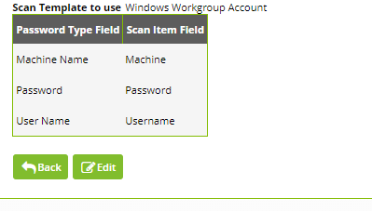

## Copy Secret template

* Navigate to admin 🡪 Secret Templates
* Copy Build-In Window Account template to Windows Workgroup account
* Navigate to copied secret template then configure password changing
* Specify the password changer which we created in Step 4

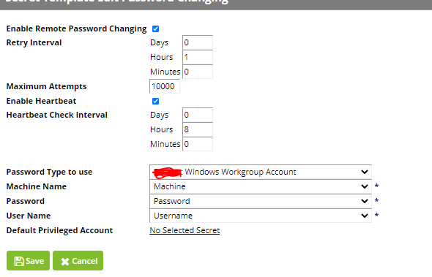

## Create Discovery Source

* Navigate to Admin 🡪 Discovery 🡪 Edit Discovery sources
* Create new discovery source and select discovery type as Unix Discovery Source

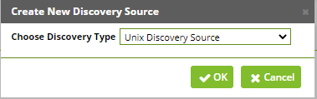

* Specify the Discovery Source Name, Host range (Specify the IP Address or Host name in lines – IP range is not supported) and privileged account (Select any scan account we will be deleting it later stage)
* Once Discovery source is created – delete the Find machine, Find account scanners
* Add new machine scanner and select the machine scanner name as per the step 3.a. Specify the same IP Addresses mentioned in the Host range input

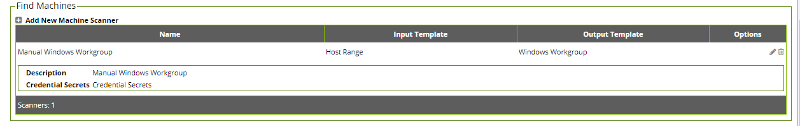

* Add new account scanner and select the account name as per the step 3.b and assign the privileged account/scan account which has local admin privileges on the machine. It’s recommended to use Secret Search filter.

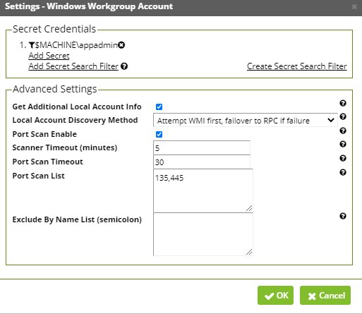

* Run Discovery Scan and Computer Scan.